CITIZENS ADVICE BRIDPORT & DISTRICT – WHO WE ARE

Our Trustee Board is made up of a number of unpaid volunteers from the local community. Brief details of our current Trustee Board are as follows:

JIM SMYLLIE – Chair
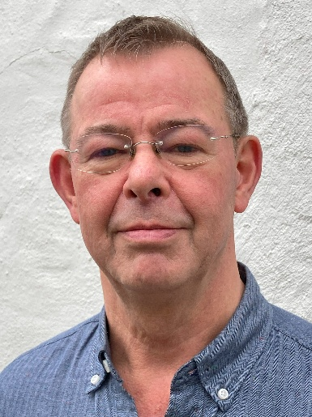

After an early career in the arts, Jim spent twenty-five years in senior planning, strategy and management roles in the public sector and government, including ten years in the NHS. The final years of his executive career were at Board level in Natural England, the national government advisory and delivery body for nature. More recently Jim was a Lay Member in the NHS, chaired one of the National Trust’s Regional Advisory Boards, and was a Trustee of the Landscape Institute. He is presently a Trustee of Artsreach, which brings professional live arts performances to village halls and community settings across Dorset and has served for three years as a Trustee of the Dorset National History and Archaeological Society, which runs the Dorset Museum and Art Gallery. Jim lives in Netherbury in west Dorset.

KEITH WILSON – Treasurer
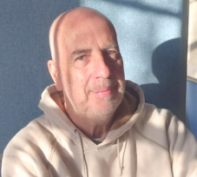

Keith grew up in Lancashire before moving to London via Sydney. He had a career as a management accountant in both the public and private sectors, before relocating to Bridport. He enjoys sport and the occasional pint.
MIKE FLETCHER – Company Secretary and Lead Trustee: Influence Planning & Governance


Most of Mike’s career was involved in IT in some form or another: working for an IT company, a major oil company (including a period in the Middle East) and then a management consultancy. He was a technical specialist, an IT manager, and also worked in HR Systems’ project management and Reward. For the final eight years of his career, he lectured in Information Systems’ Management, Project Management and General Management at university business schools.
Since moving to Dorset in 2017 he has been a member of several NHS public engagement groups.

LAVINIA SONNENBERG - Lead trustee: Income generation, Partnerships and Marketing


Lavinia has more than 20 years’ experience at strategic and operational levels in private sector hospital management and corporate wellness service provision. She has many successes in the areas of business transformation and optimisation of service provision, most notably in the mental health sector, running a 24\7 contact centre and a national network of counselling clinics. Having spent most of her working career in South Africa Lavinia is passionate about ensuring that workplaces and communities understand and embrace diversity, and that space is created for everyone to live the life they are capable of achieving.
Lavinia has been the Chair of the Johannesburg branch of the Businesswomen’s Association of South Africa and Chair of a residential housing association that succeeded in preserving greenbelt areas that were in decline because of a housing development boom. Since moving to England, she has continued to focus on business optimisation and consultancy. A 3-year term as an elected parish Councilor in East Devon has kept up her keen interest in community resilience.
Lavinia was drawn to Citizens Advice because it acts for those who feel helpless in the face of adverse circumstances, and it facilitates a ‘joined up approach’ to supporting citizens in need.

JACQUI BISHOP - Lead trustee: Accessible Advice
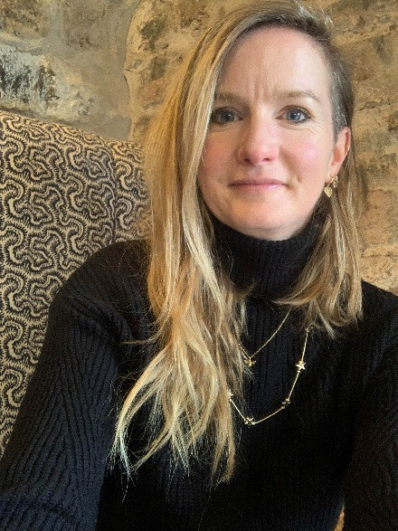

Jacqui works as a civil servant within central government. As a Human Resources Chartered Institute for Personnel and Development qualified professional, she is experienced at leading and supporting change across an organisation, improving the quality of line management relationships within the organisation and driving strategic people projects to conclusion on time and to budget. During a career break, Jacqui joined Bridport Citizens Advice as a volunteer advisor in 2022 and switched to volunteer governor in 2023 when she returned to work.

JAMIE SCOTT - Lead trustee: Sustainable Resourcing: IT and premises
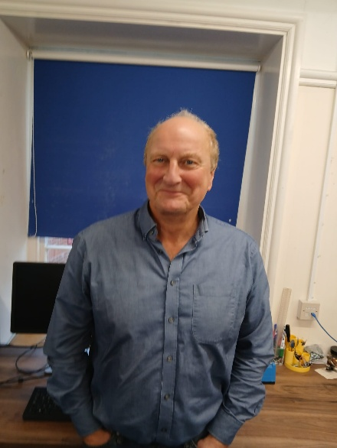

Jamie retired to Bridport in 2023 from north London. His career was in the private sector leading various programmes and projects in business transformation. He also spent several years managing IT departments in the entertainment sector. Jamie is chair of trustees at a secondary academy in north London and joined the CA board of trustees in Bridport in 2024.

Linda Child – Lead Trustee: Workforce
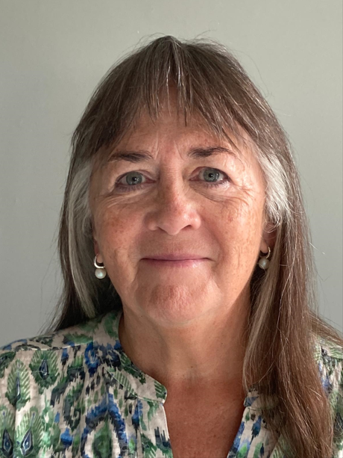

After studying Law at Liverpool University, Linda moved to Antwerp in Belgium and trained in Brussels as an American & International tax law specialist, working extensively in Europe and the US. In later years she was a lecturer in law & taxation and has also worked as a CAB adviser. Since retiring to Bridport at the end of 2018, Linda was Chair of the Trustee Board at a local residential care home for 4 years.

